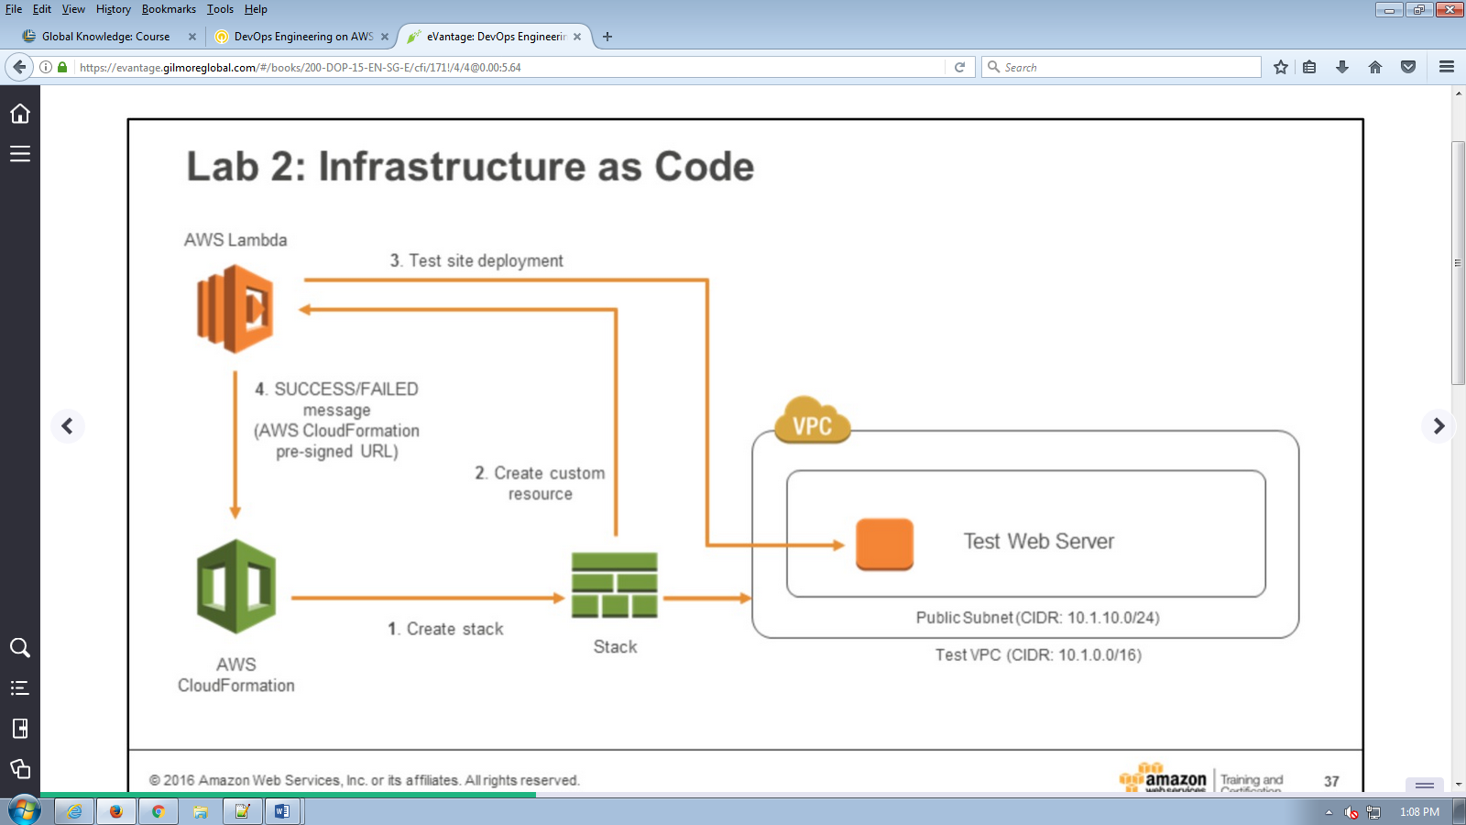

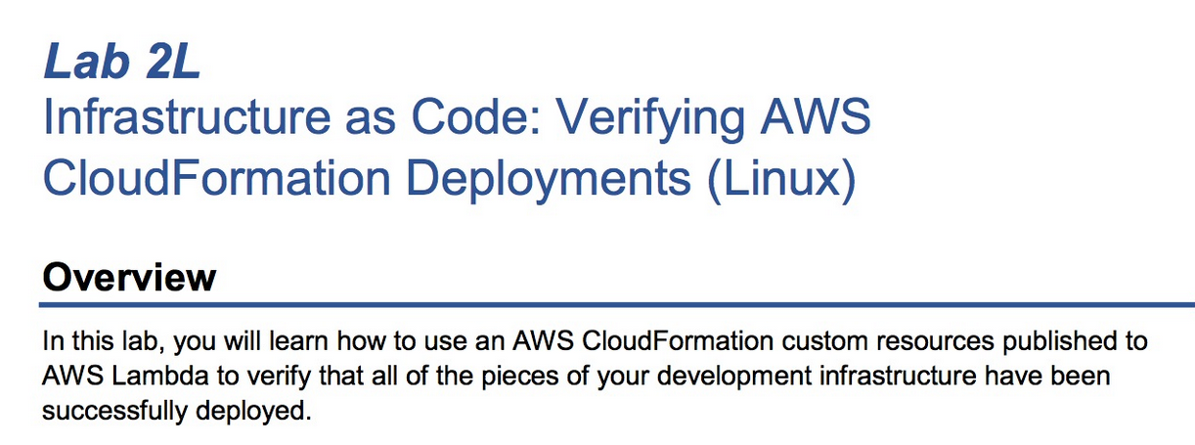 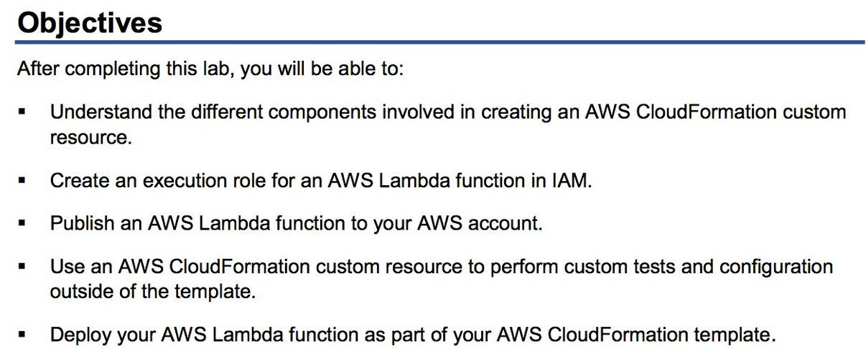 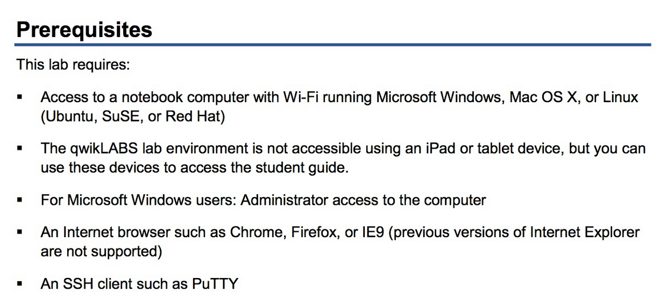 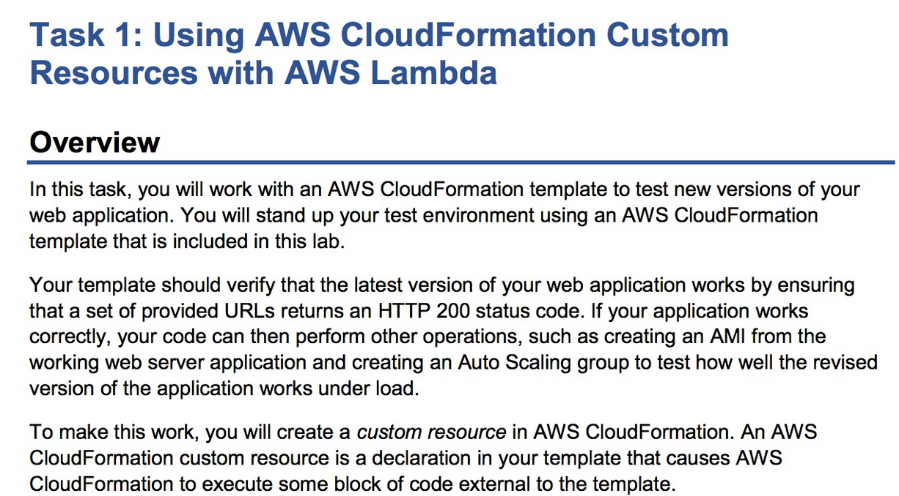 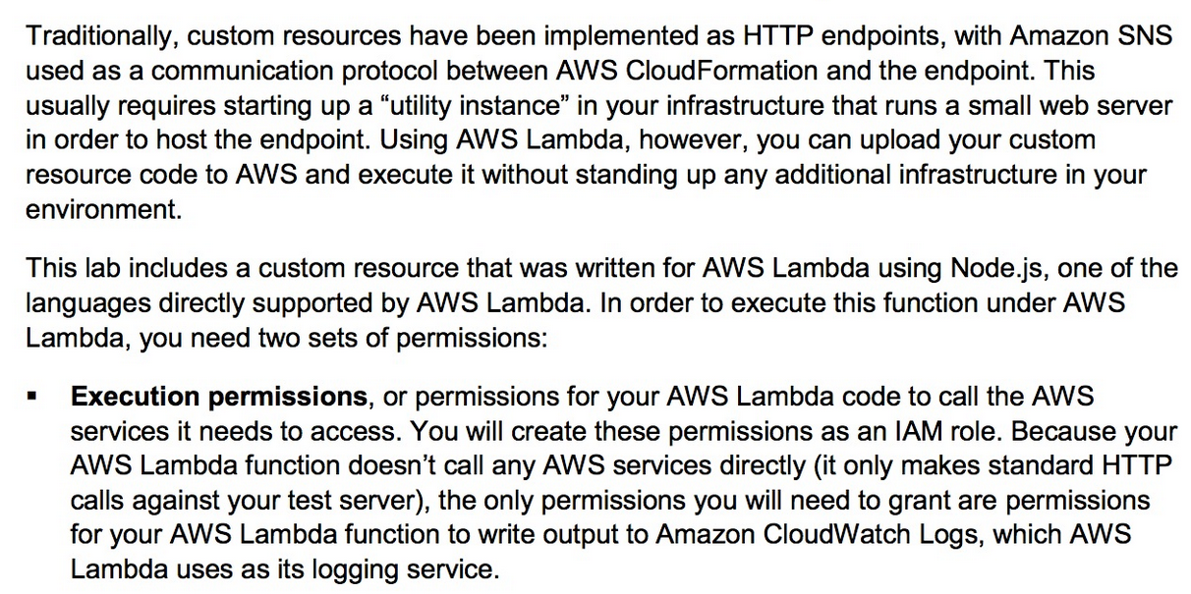 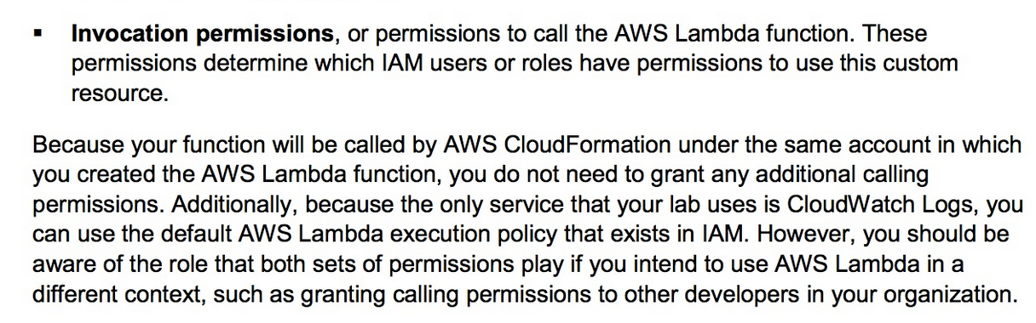 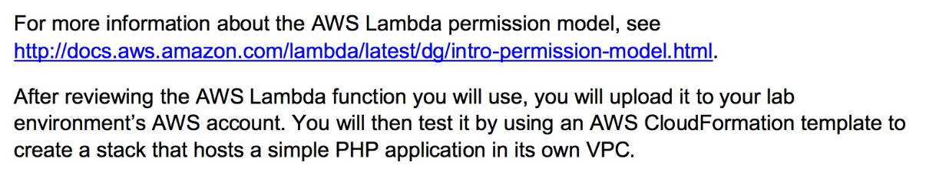 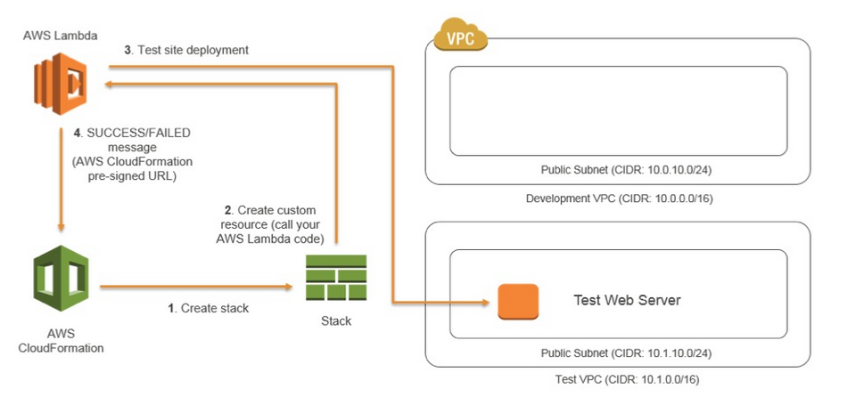 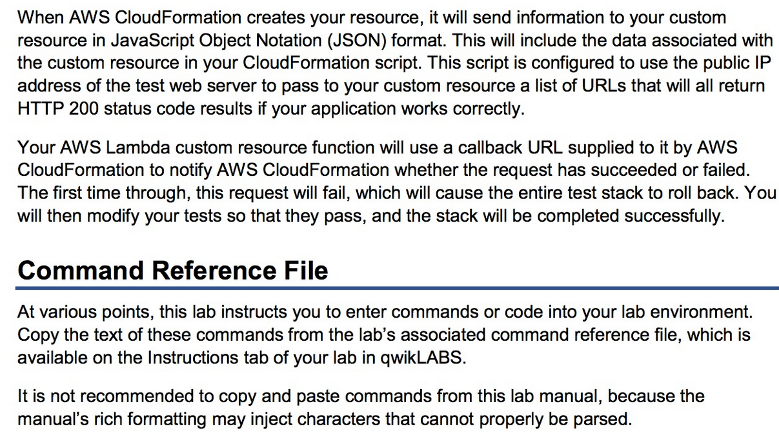 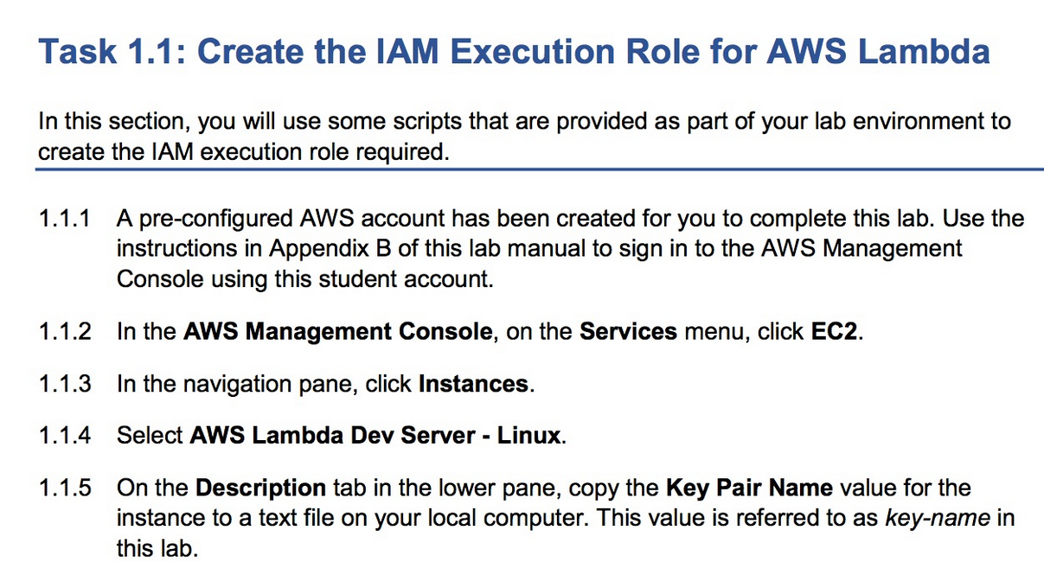 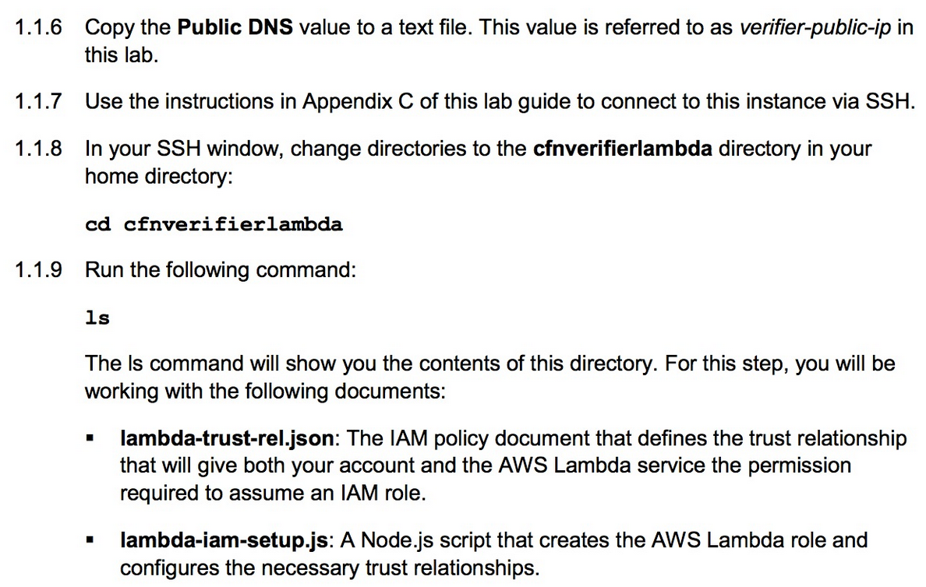

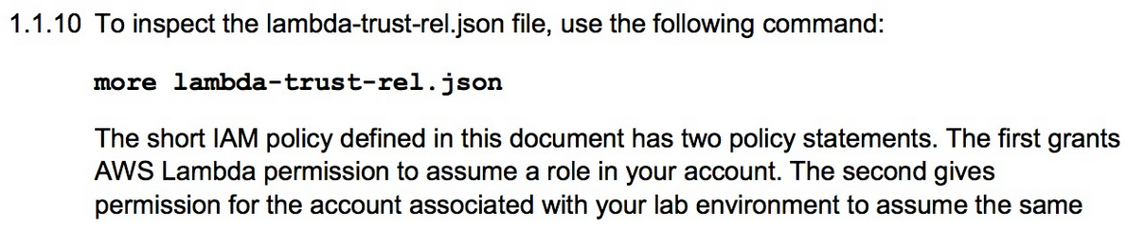 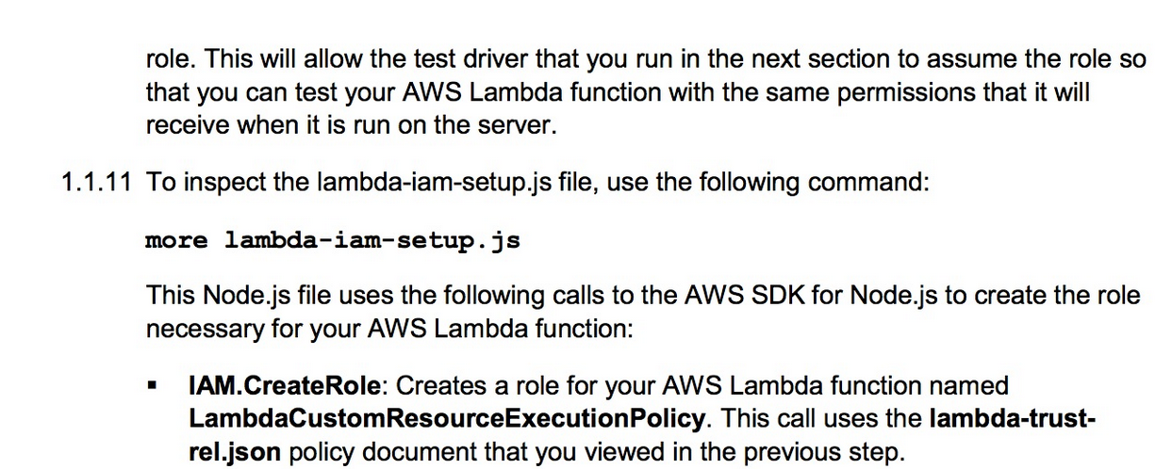 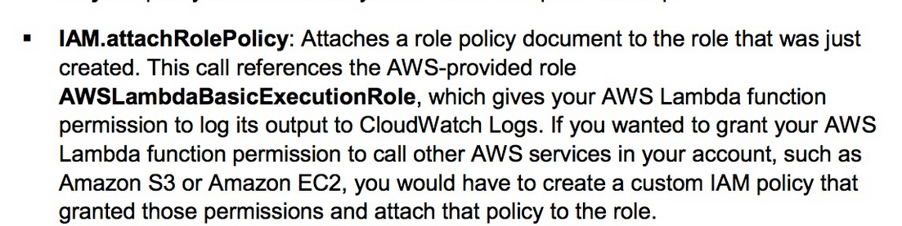 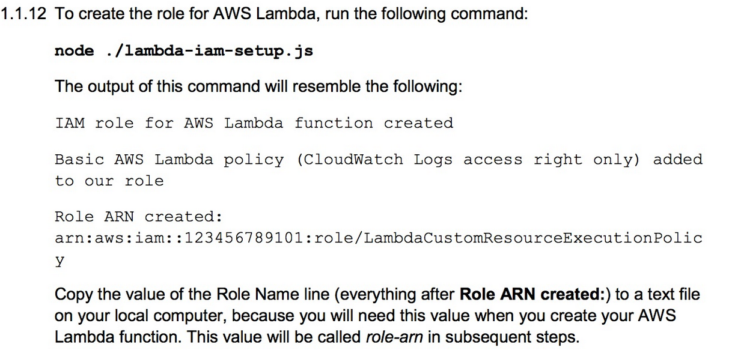 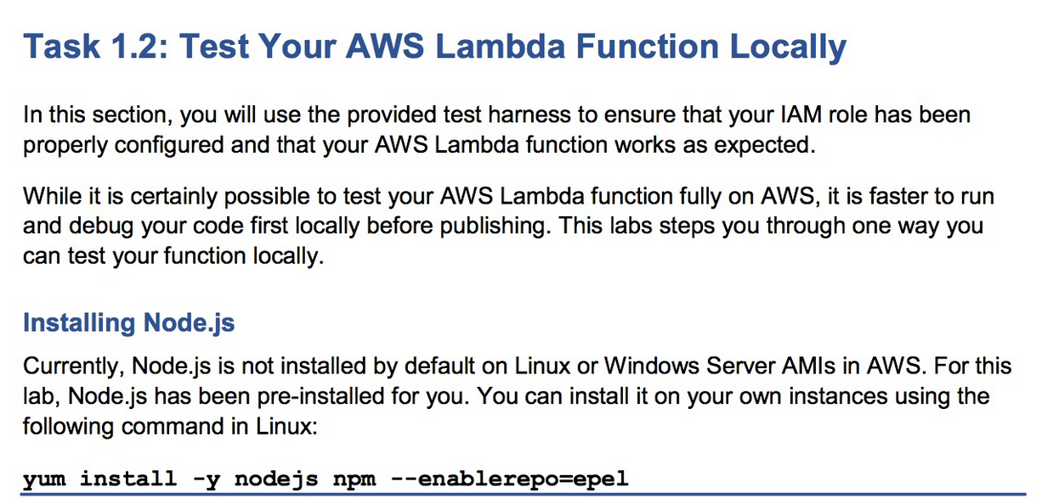 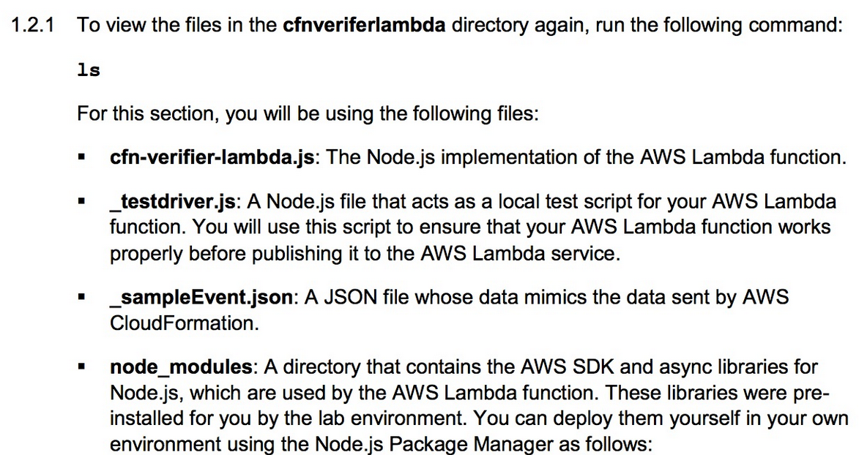 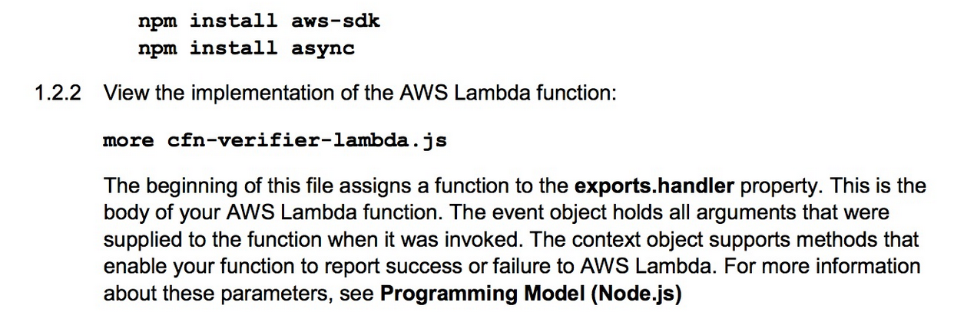 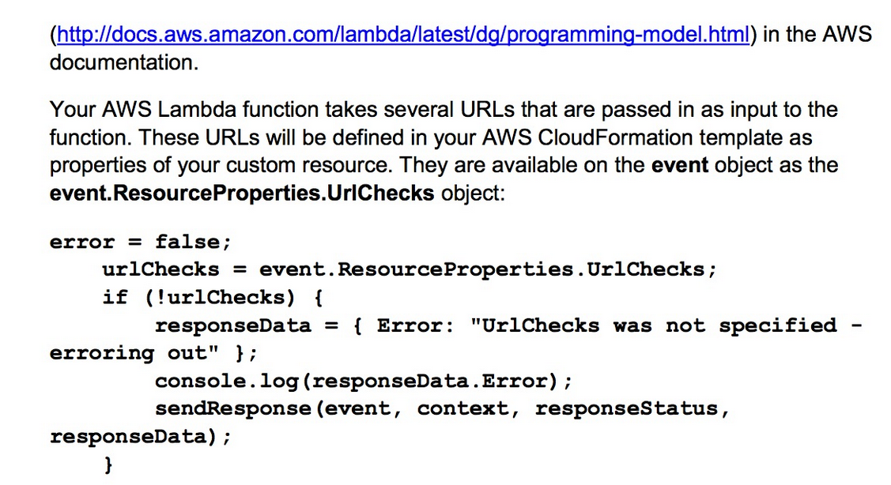 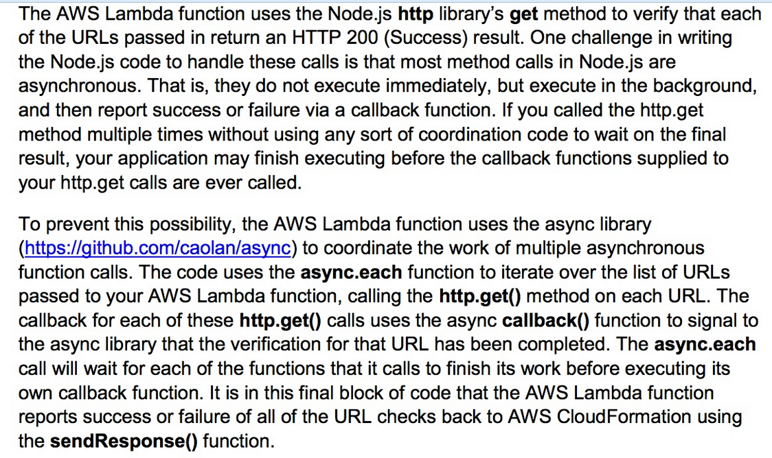 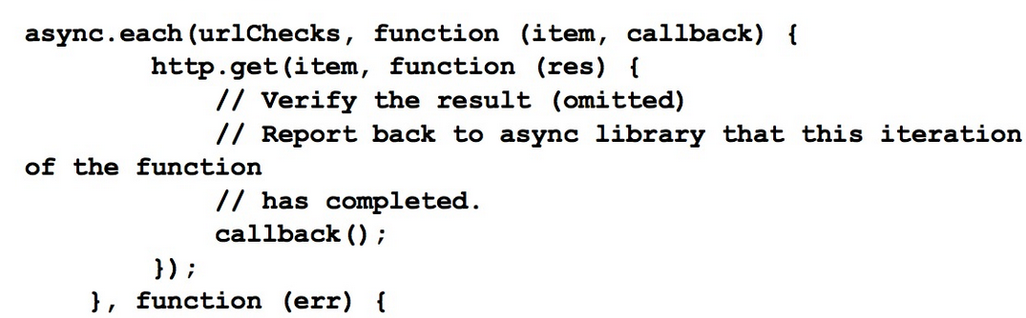 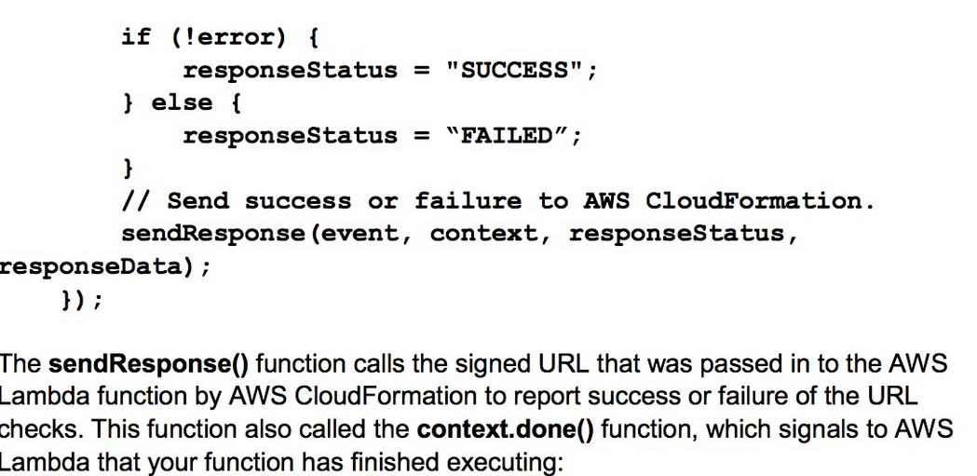 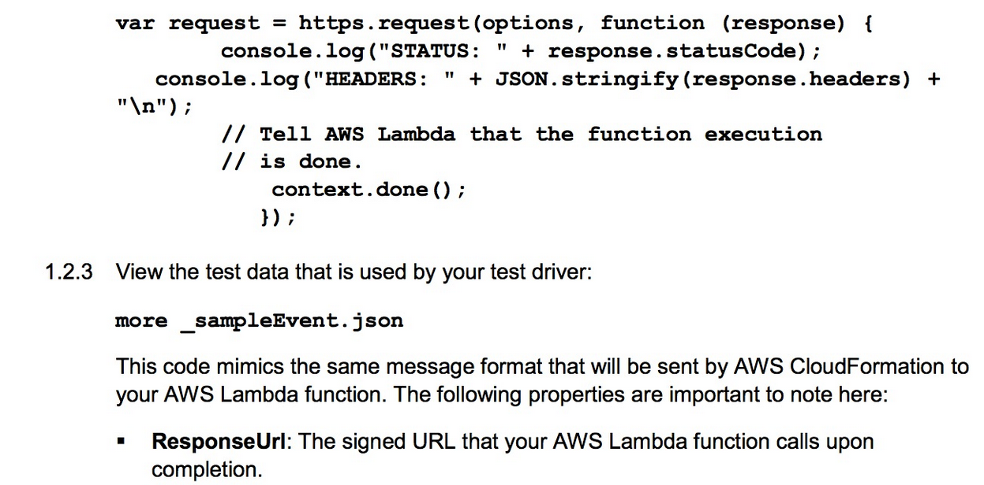 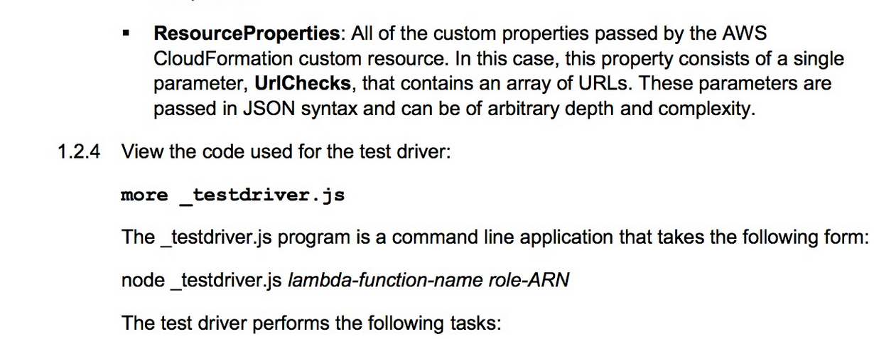 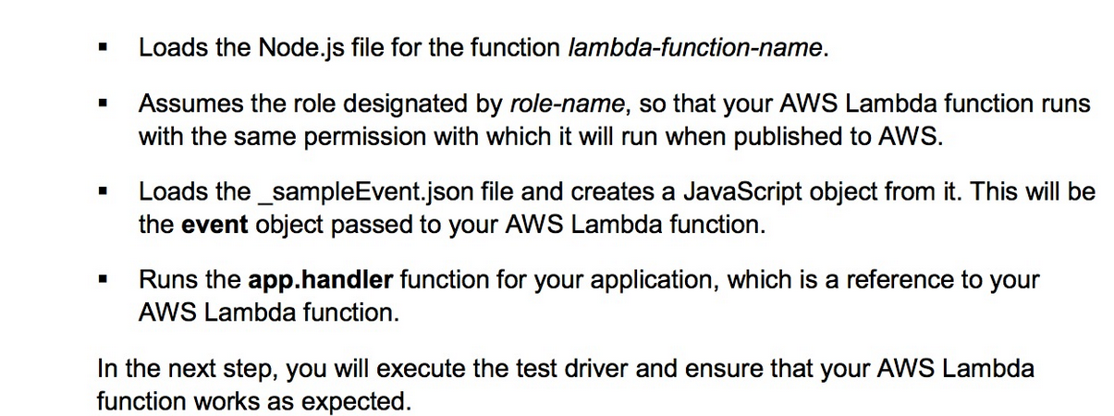 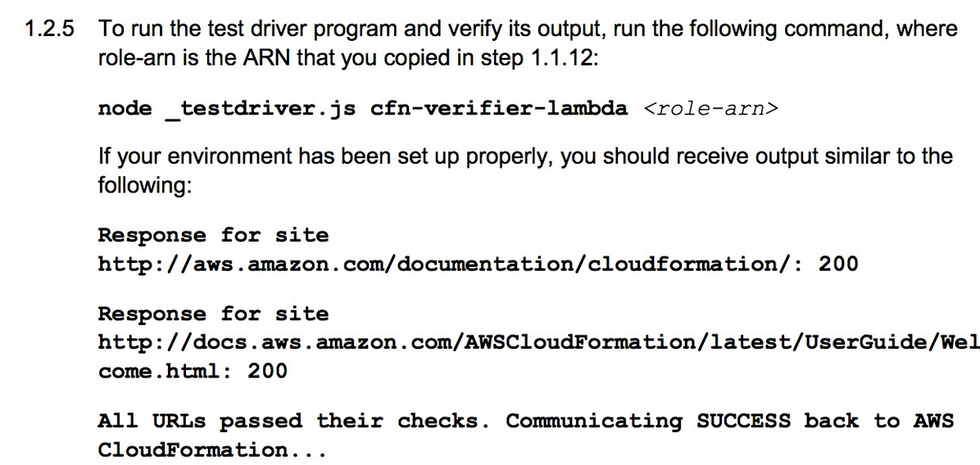 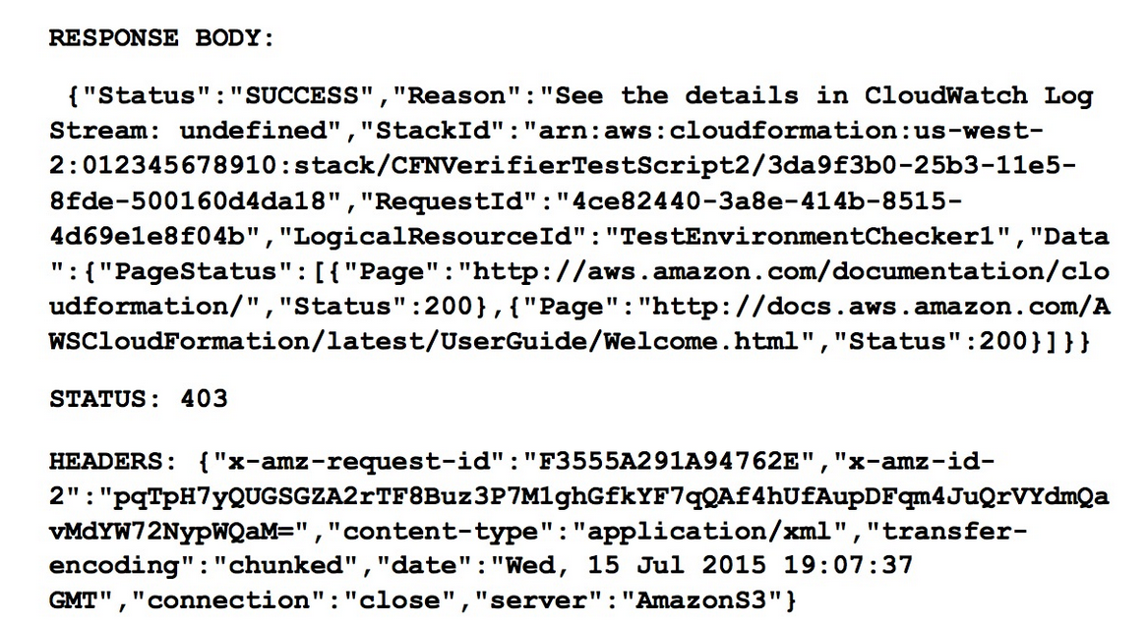 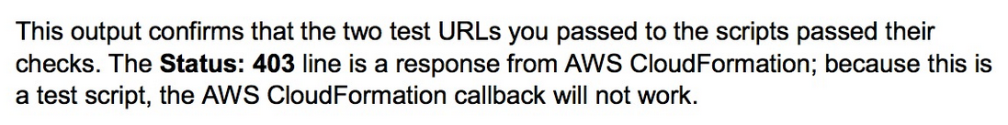

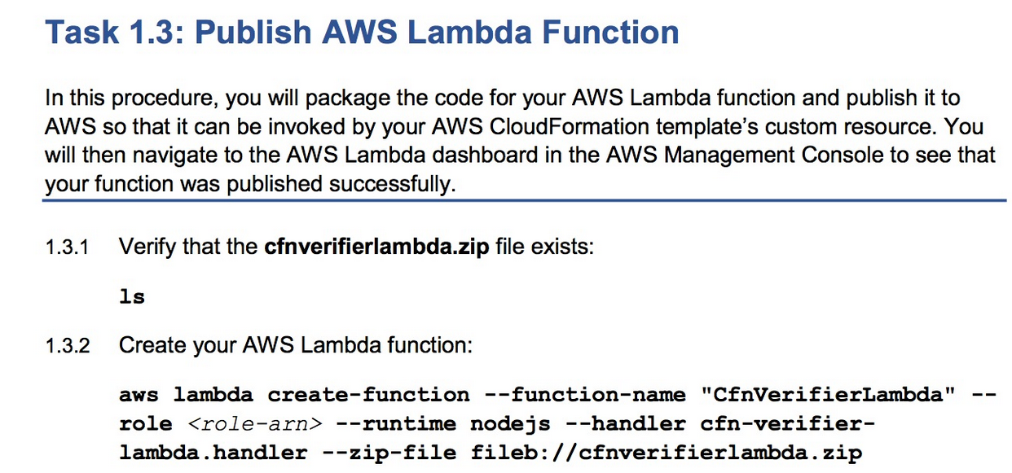 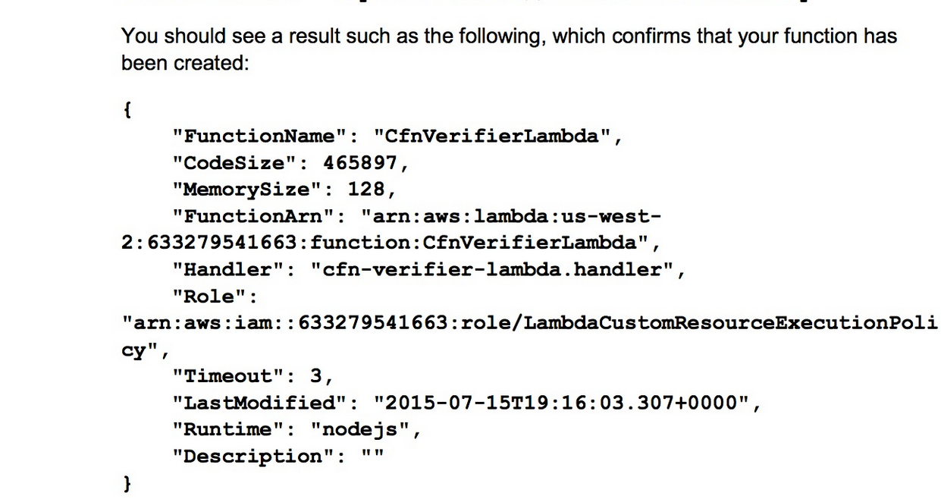 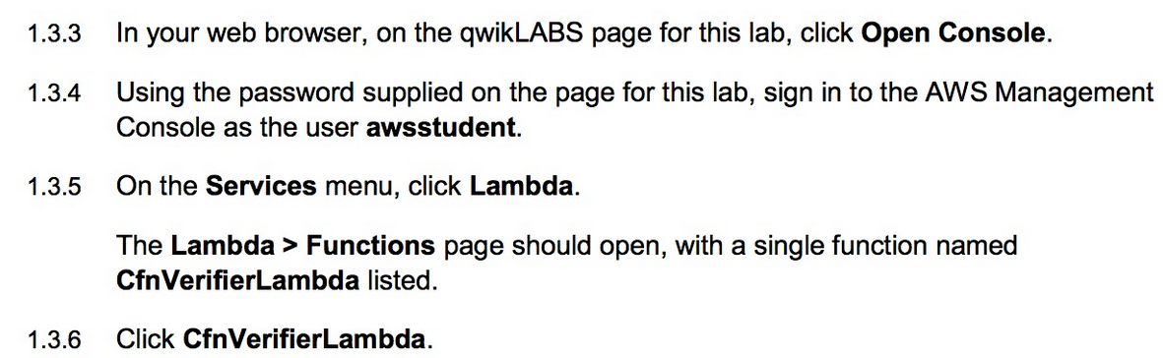 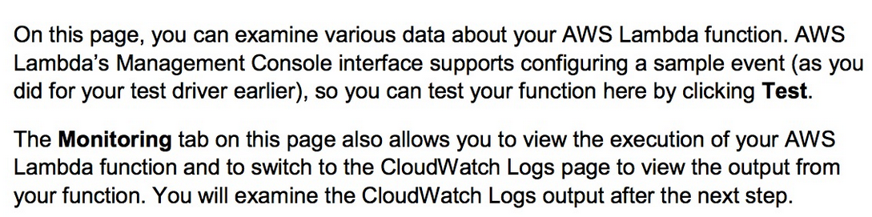 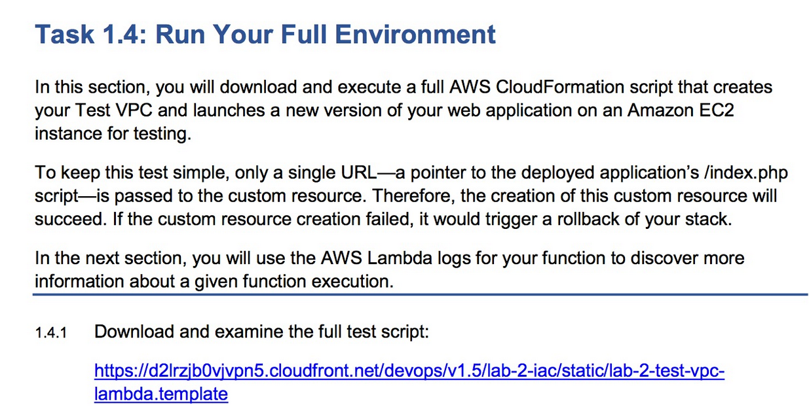

SCRIPT:

{

"AWSTemplateFormatVersion": "2010-09-09",

"Parameters": {

"TestVPCCIDR": {

"Description": "CIDR Block for Developer VPC",

"Type": "String",

"Default": "10.1.0.0/16",

"AllowedValues": [

"10.1.0.0/16"

]

},

"TestPublicSubnetCIDR": {

"Description": "TestEnv Public Subnet",

"Type": "String",

"Default": "10.1.10.0/24",

"AllowedValues": [

"10.1.10.0/24"

]

},

"KeyName": {

"Description": "Key Pair Name",

"Type": "AWS::EC2::KeyPair::KeyName"

}

},

"Mappings": {

"AmazonLinuxAMI": {

"us-east-1": {

"AMI": "ami-1ecae776"

},

"us-west-1": {

"AMI": "ami-d114f295"

},

"us-west-2": {

"AMI": "ami-e7527ed7"

},

"eu-west-1": {

"AMI": "ami-a10897d6"

},

"eu-central-1": {

"AMI": "ami-a8221fb5"

},

"sa-east-1": {

"AMI": "ami-b52890a8"

},

"ap-southeast-1": {

"AMI": "ami-68d8e93a"

},

"ap-southeast-2": {

"AMI": "ami-fd9cecc7"

},

"ap-northeast-1": {

"AMI": "ami-cbf90ecb"

}

}

},

"Resources": {

"TestVPC": {

"Type": "AWS::EC2::VPC",

"Properties": {

"CidrBlock": {

"Ref": "TestVPCCIDR"

},

"EnableDnsSupport": "true",

"EnableDnsHostnames": "true",

"Tags": [

{

"Key": "VPC",

"Value": "Test VPC"

},

{

"Key": "Name",

"Value": "Test VPC"

}

]

}

},

"TestInternetGateway": {

"Type": "AWS::EC2::InternetGateway",

"DependsOn": "TestVPC"

},

"TestAttachGateway": {

"Type": "AWS::EC2::VPCGatewayAttachment",

"DependsOn": [

"TestVPC",

"TestInternetGateway"

],

"Properties": {

"VpcId": {

"Ref": "TestVPC"

},

"InternetGatewayId": {

"Ref": "TestInternetGateway"

}

}

},

"TestPublicSubnet": {

"Type": "AWS::EC2::Subnet",

"DependsOn": "TestAttachGateway",

"Properties": {

"VpcId": {

"Ref": "TestVPC"

},

"CidrBlock": {

"Ref": "TestPublicSubnetCIDR"

},

"AvailabilityZone": {

"Fn::Select": [

"0",

{

"Fn::GetAZs": ""

}

]

},

"Tags": [

{

"Key": "Name",

"Value": "Test Public Subnet"

}

]

}

},

"TestPublicRouteTable": {

"Type": "AWS::EC2::RouteTable",

"DependsOn": [

"TestVPC",

"TestAttachGateway"

],

"Properties": {

"VpcId": {

"Ref": "TestVPC"

},

"Tags": [

{

"Key": "Name",

"Value": "Test Public Route Table"

}

]

}

},

"TestPublicRoute": {

"Type": "AWS::EC2::Route",

"DependsOn": [

"TestPublicRouteTable",

"TestAttachGateway"

],

"Properties": {

"RouteTableId": {

"Ref": "TestPublicRouteTable"

},

"DestinationCidrBlock": "0.0.0.0/0",

"GatewayId": {

"Ref": "TestInternetGateway"

}

}

},

"TestPublicSubnetRouteTableAssociation": {

"Type": "AWS::EC2::SubnetRouteTableAssociation",

"DependsOn": [

"TestPublicRouteTable",

"TestPublicSubnet",

"TestAttachGateway"

],

"Properties": {

"SubnetId": {

"Ref": "TestPublicSubnet"

},

"RouteTableId": {

"Ref": "TestPublicRouteTable"

}

}

},

"WebServerSecurityGroup": {

"Type": "AWS::EC2::SecurityGroup",

"DependsOn": "TestAttachGateway",

"Properties": {

"GroupDescription": "Security Group for Web server",

"VpcId": {

"Ref": "TestVPC"

},

"Tags": [

{

"Key": "Name",

"Value": "WebServerSecurityGroup"

},

{

"Key": "InstanceType",

"Value": "General"

}

],

"SecurityGroupEgress": [

{

"IpProtocol": "tcp",

"FromPort": "0",

"ToPort": "65535",

"CidrIp": "0.0.0.0/0"

},

{

"IpProtocol": "udp",

"FromPort": "0",

"ToPort": "65535",

"CidrIp": "0.0.0.0/0"

}

],

"SecurityGroupIngress": [

{

"IpProtocol": "tcp",

"FromPort": "22",

"ToPort": "22",

"CidrIp": "0.0.0.0/0"

},

{

"IpProtocol": "tcp",

"FromPort": "80",

"ToPort": "80",

"CidrIp": "0.0.0.0/0"

}

]

}

},

"WebServerWaitHandle01": {

"Type": "AWS::CloudFormation::WaitConditionHandle",

"Properties": {}

},

"WebServerWaitCondition01": {

"Type": "AWS::CloudFormation::WaitCondition",

"DependsOn": "TestWebServer",

"Properties": {

"Handle": {

"Ref": "WebServerWaitHandle01"

},

"Timeout": "1800"

}

},

"TestWebServer": {

"Type": "AWS::EC2::Instance",

"DependsOn": [

"TestPublicSubnet",

"WebServerSecurityGroup",

"TestAttachGateway"

],

"Properties": {

"KeyName": {

"Ref": "KeyName"

},

"ImageId": {

"Fn::FindInMap": [

"AmazonLinuxAMI",

{

"Ref": "AWS::Region"

},

"AMI"

]

},

"InstanceType": "t2.medium",

"NetworkInterfaces": [

{

"DeviceIndex": "0",

"AssociatePublicIpAddress": "true",

"SubnetId": {

"Ref": "TestPublicSubnet"

},

"GroupSet": [

{

"Ref": "WebServerSecurityGroup"

}

]

}

],

"Tags": [

{

"Key": "Name",

"Value": "TestWebServer"

}

],

"UserData": {

"Fn::Base64": {

"Fn::Join": [

"",

[

"#!/bin/bash\n",

"yum -y update \n",

"mkdir /home/ec2-user/.aws \n",

"cat > /home/ec2-user/.aws/config <<EOF\n",

"[default]\n",

"region = ",

{

"Ref": "AWS::Region"

},

"\n",

"EOF\n",

"chown -R ec2-user:ec2-user /home/ec2-user/.aws\n",

"cd /home/ec2-user\n",

"yum groupinstall -y \"Web Server\" \"PHP Support\"\n",

"chkconfig httpd on\n",

"cd /var/www/html\n",

"wget https://d2lrzjb0vjvpn5.cloudfront.net/devops/v1.5/lab-2-iac/static/ec2-info.zip\n",

"unzip ec2-info.zip\n",

"service httpd start 2>/home/ec2-user/errors.txt\n",

"/opt/aws/bin/cfn-signal -s true '",

{

"Ref": "WebServerWaitHandle01"

},

"'\n"

]

]

}

}

}

},

"TestEnvironmentChecker1": {

"Type": "Custom::TestEnvironmentChecker",

"DependsOn": [

"WebServerWaitCondition01"

],

"Version": "1.0",

"Properties": {

"ServiceToken": { "Fn::Join": [ "", [ "arn:aws:lambda:", { "Ref": "AWS::Region" }, ":", { "Ref": "AWS::AccountId" }, ":function:CfnVerifierLambda" ] ] },

"UrlChecks": [

{

"Fn::Join": [

"",

[

"http://",

{

"Fn::GetAtt": [

"TestWebServer",

"PublicIp"

]

},

"/index.php"

]

]

}

]

}

}

}

}

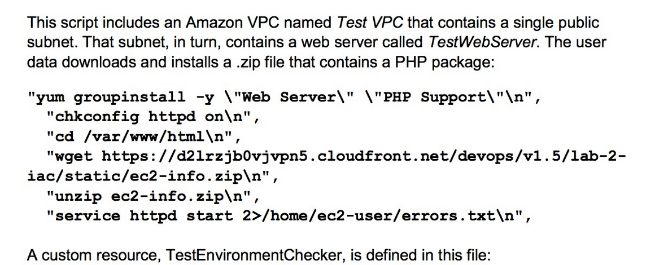 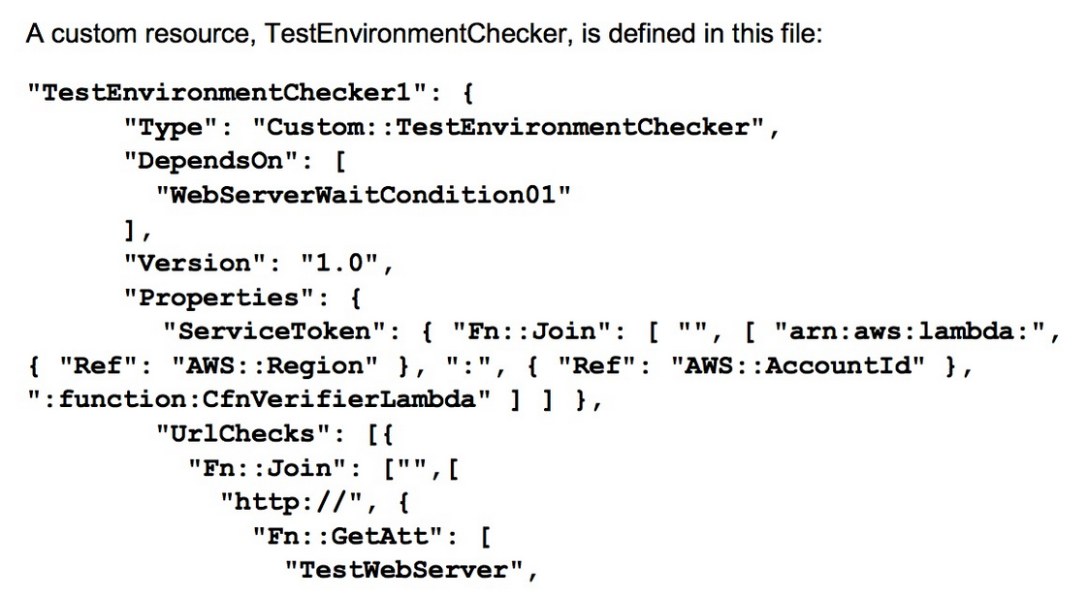 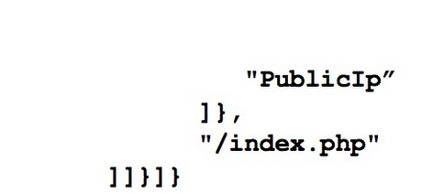 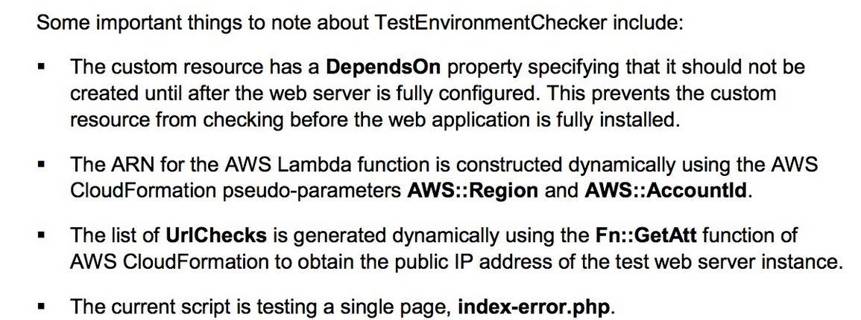 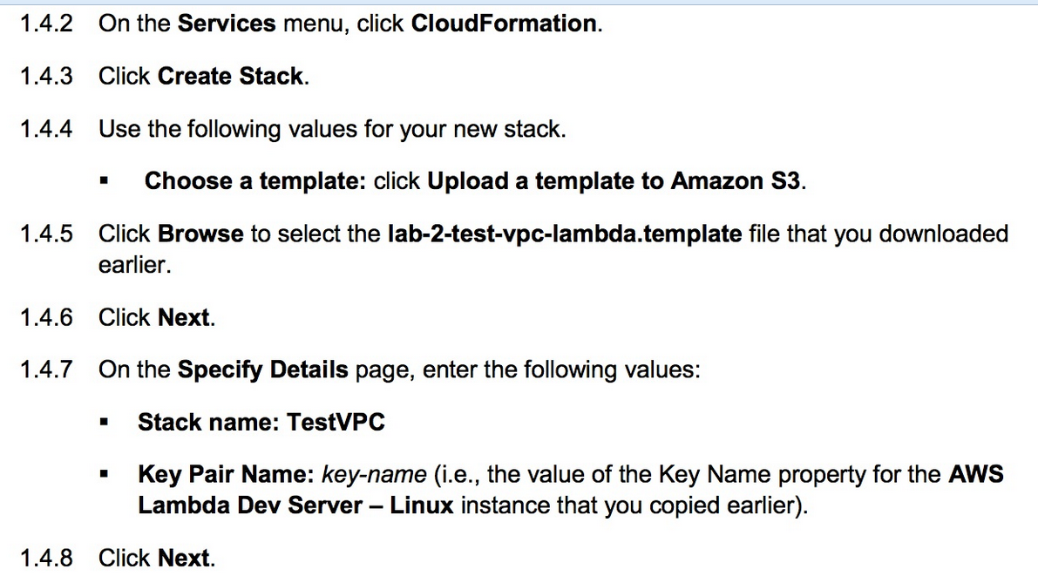 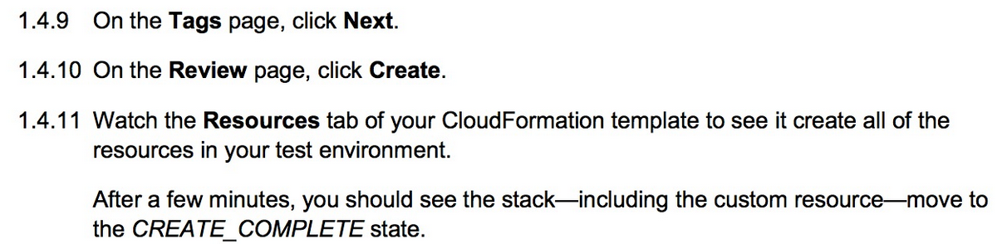 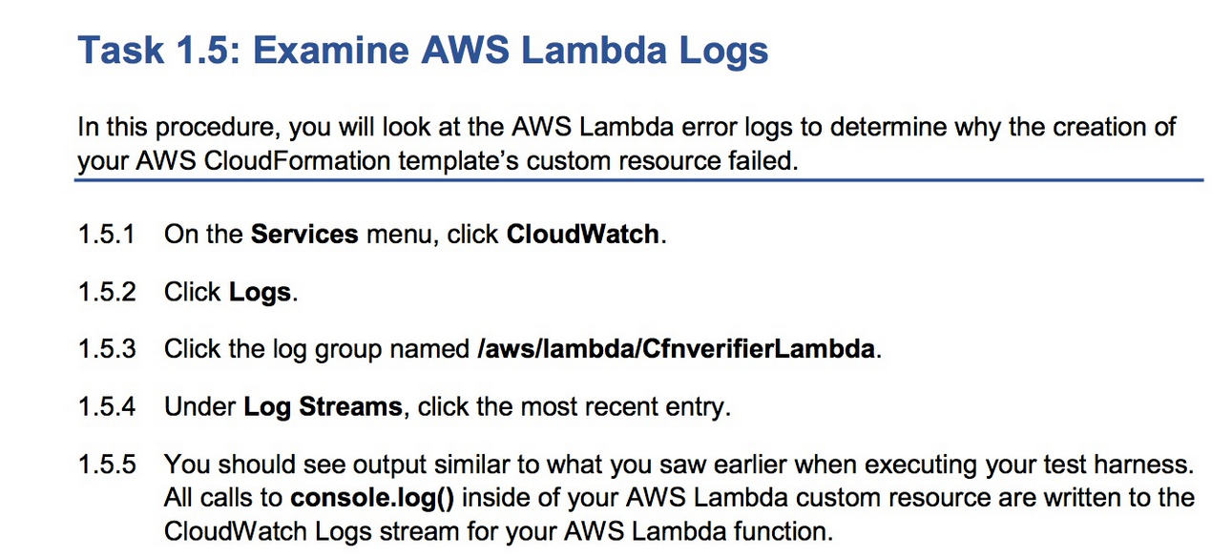 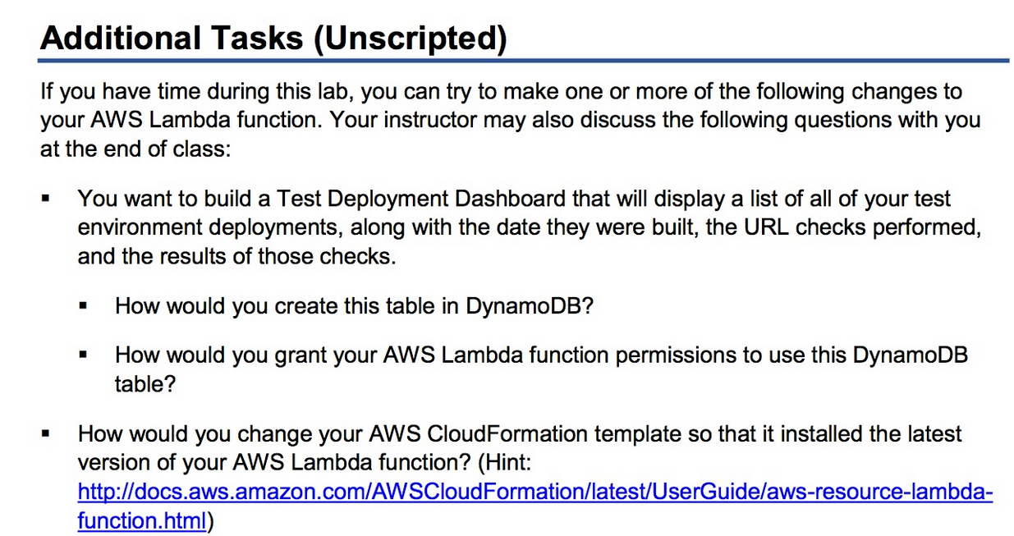

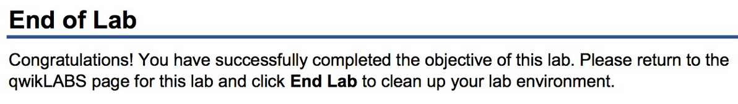

DevOps Engineering on AWS: Lab 2 - Infrastructure as Code: Verifying AWS CloudFormation Deployments - Linux - v1.5

==================================================================================================================

Using this command reference.

==================================================================================================================

1. Locate the section you need. Each section in this file matches a section in the lab instructions.

2. Replace items in angle brackets - < > - with appropriate values. For example, in this command you would replace the value - <JobFlowID> - (including the angle brackets) with the parameter indicated in the lab instructions:

elastic-mapreduce --list <JobFlowID>. You can also use find and replace to change bracketed parameters in bulk.

3. Do NOT enable the Word Wrap feature in Windows Notepad or the text editor you use to view this file.

++++1. Task: Using AWS CloudFormation Custom Resources

==================================================================================================================

1.1 Review the AWS Lambda Function

==================================================================================================================

1.1.12 Create the execution role for AWS Lambda

node lambda-iam-setup.js

==================================================================================================================

1.2 Test Your AWS Lambda Function Locally

==================================================================================================================

1.2.5 Test the function locally

node _testdriver.js cfn-verifier-lambda <role-arn>

==================================================================================================================

1.3 Publish AWS Lambda Function

==================================================================================================================

1.3.2 Publish the AWS Lambda function

aws lambda create-function --function-name "CfnVerifierLambda" --role <role-arn> --runtime nodejs4.3 --handler cfn-verifier-lambda.handler --zip-file fileb://cfnverifierlambda.zip

==================================================================================================================

1.4 Run Your Full Environment

==================================================================================================================

1.4.1 Download and examine the test script

https://d2lrzjb0vjvpn5.cloudfront.net/devops/v1.5/lab-2-iac/static/lab-2-test-vpc-lambda.template

© 2017 Amazon Web Services, Inc. or its affiliates. All rights reserved.

**USE APPENDIX A NOT C :- AS YOU ARE IN WINDOWS NOT LINUX BOX**

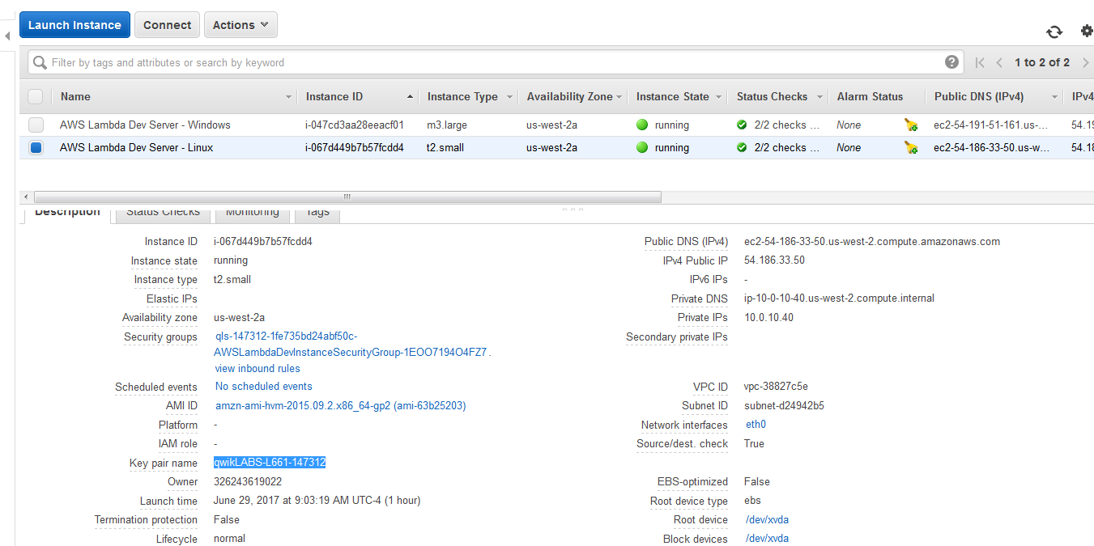

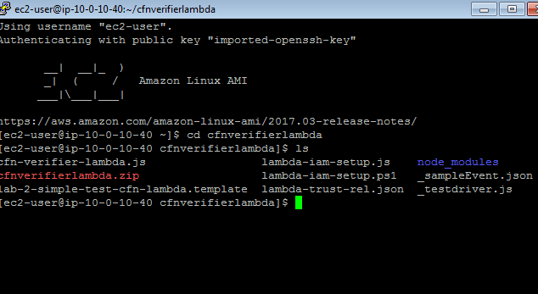

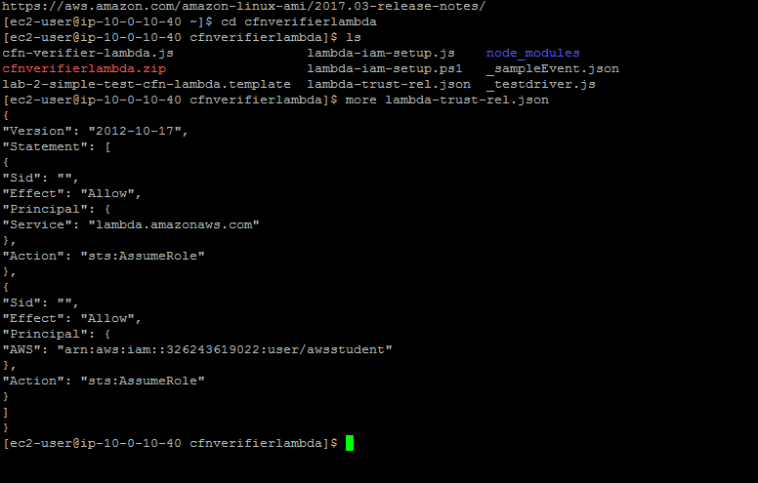

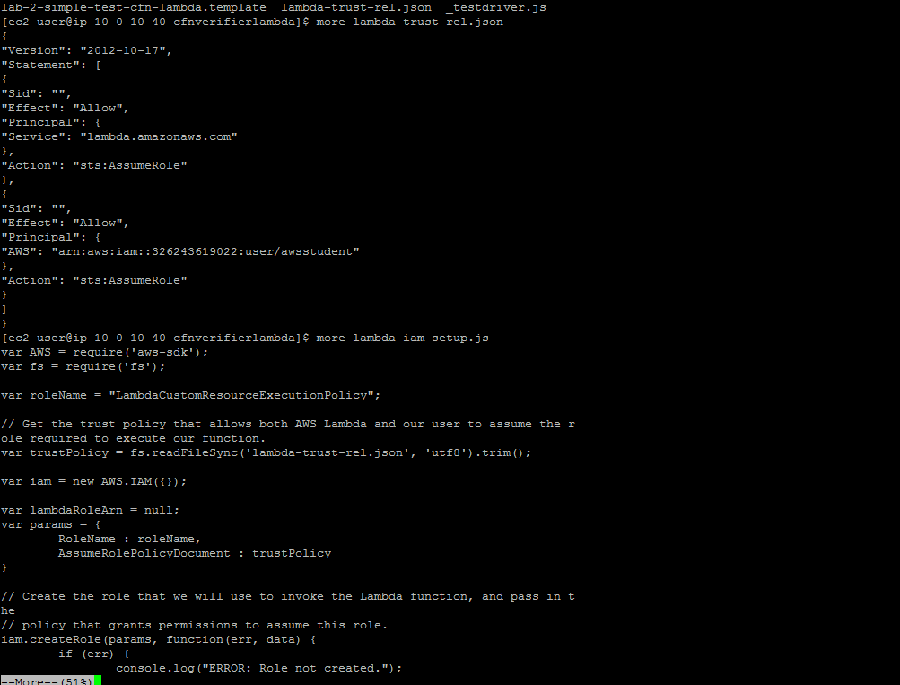

TO CREATE ROLE

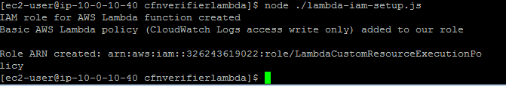

Role ARN created: arn:aws:iam::326243619022:role/LambdaCustomResourceExecutionPolicy

1.2 Test Your AWS Lambda Function Locally

==================================================================================================================

1.2.5 Test the function locally

node _testdriver.js cfn-verifier-lambda arn:aws:iam::326243619022:role/LambdaCustomResourceExecutionPolicy

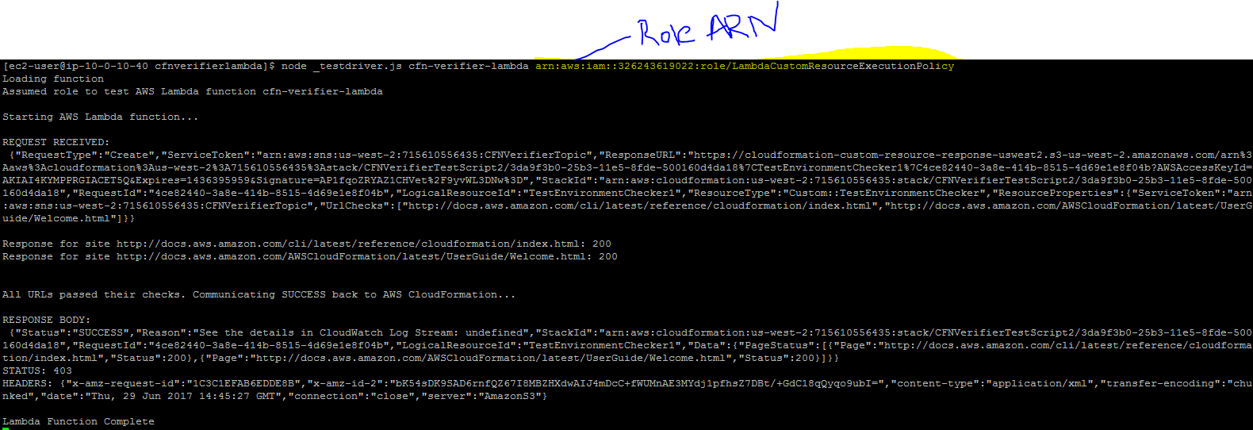

1.3 Publish AWS Lambda Function

==================================================================================================================

1.3.2 Publish the AWS Lambda function

aws lambda create-function --function-name "CfnVerifierLambda" --role <role-arn> --runtime nodejs4.3 --handler cfn-verifier-lambda.handler --zip-file fileb://cfnverifierlambda.zip

aws lambda create-function --function-name "CfnVerifierLambda" --role arn:aws:iam::326243619022:role/LambdaCustomResourceExecutionPolicy --runtime nodejs4.3 --handler cfn-verifier-lambda.handler --zip-file fileb://cfnverifierlambda.zip

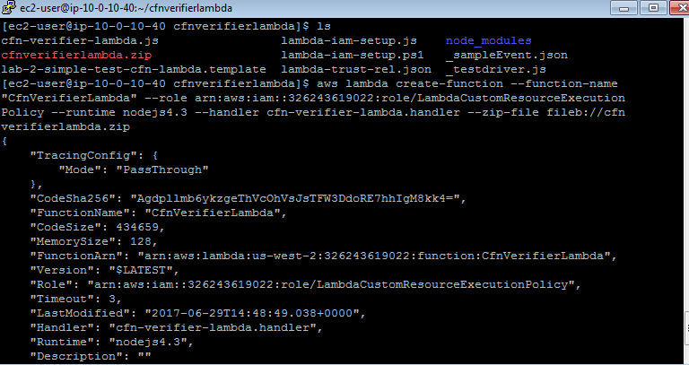

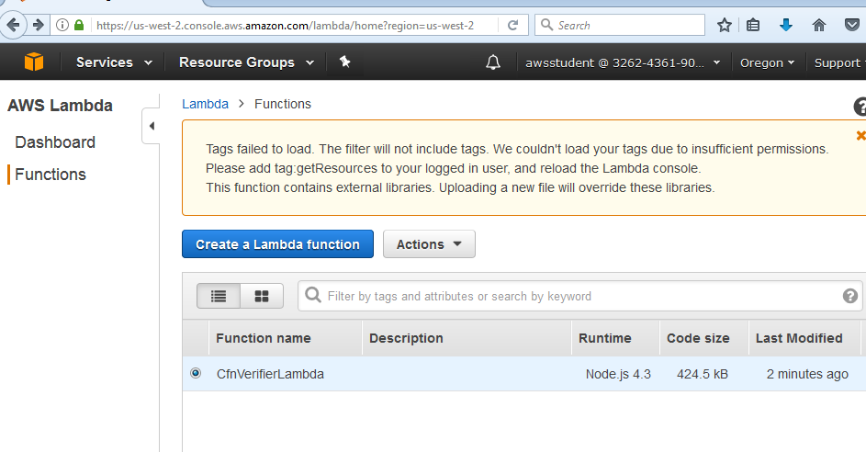

==================================================================================================================

1.4 Run Your Full Environment

==================================================================================================================

1.4.1 Download and examine the test script

https://d2lrzjb0vjvpn5.cloudfront.net/devops/v1.5/lab-2-iac/static/lab-2-test-vpc-lambda.template

{

"AWSTemplateFormatVersion": "2010-09-09",

"Parameters": {

"TestVPCCIDR": {

"Description": "CIDR Block for Developer VPC",

"Type": "String",

"Default": "10.1.0.0/16",

"AllowedValues": [

"10.1.0.0/16"

]

},

"TestPublicSubnetCIDR": {

"Description": "TestEnv Public Subnet",

"Type": "String",

"Default": "10.1.10.0/24",

"AllowedValues": [

"10.1.10.0/24"

]

},

"KeyName": {

"Description": "Key Pair Name",

"Type": "AWS::EC2::KeyPair::KeyName"

}

},

"Mappings": {

"AmazonLinuxAMI": {

"us-east-1": {

"AMI": "ami-1ecae776"

},

"us-west-1": {

"AMI": "ami-d114f295"

},

"us-west-2": {

"AMI": "ami-e7527ed7"

},

"eu-west-1": {

"AMI": "ami-a10897d6"

},

"eu-central-1": {

"AMI": "ami-a8221fb5"

},

"sa-east-1": {

"AMI": "ami-b52890a8"

},

"ap-southeast-1": {

"AMI": "ami-68d8e93a"

},

"ap-southeast-2": {

"AMI": "ami-fd9cecc7"

},

"ap-northeast-1": {

"AMI": "ami-cbf90ecb"

}

}

},

"Resources": {

"TestVPC": {

"Type": "AWS::EC2::VPC",

"Properties": {

"CidrBlock": {

"Ref": "TestVPCCIDR"

},

"EnableDnsSupport": "true",

"EnableDnsHostnames": "true",

"Tags": [

{

"Key": "VPC",

"Value": "Test VPC"

},

{

"Key": "Name",

"Value": "Test VPC"

}

]

}

},

"TestInternetGateway": {

"Type": "AWS::EC2::InternetGateway",

"DependsOn": "TestVPC"

},

"TestAttachGateway": {

"Type": "AWS::EC2::VPCGatewayAttachment",

"DependsOn": [

"TestVPC",

"TestInternetGateway"

],

"Properties": {

"VpcId": {

"Ref": "TestVPC"

},

"InternetGatewayId": {

"Ref": "TestInternetGateway"

}

}

},

"TestPublicSubnet": {

"Type": "AWS::EC2::Subnet",

"DependsOn": "TestAttachGateway",

"Properties": {

"VpcId": {

"Ref": "TestVPC"

},

"CidrBlock": {

"Ref": "TestPublicSubnetCIDR"

},

"AvailabilityZone": {

"Fn::Select": [

"0",

{

"Fn::GetAZs": ""

}

]

},

"Tags": [

{

"Key": "Name",

"Value": "Test Public Subnet"

}

]

}

},

"TestPublicRouteTable": {

"Type": "AWS::EC2::RouteTable",

"DependsOn": [

"TestVPC",

"TestAttachGateway"

],

"Properties": {

"VpcId": {

"Ref": "TestVPC"

},

"Tags": [

{

"Key": "Name",

"Value": "Test Public Route Table"

}

]

}

},

"TestPublicRoute": {

"Type": "AWS::EC2::Route",

"DependsOn": [

"TestPublicRouteTable",

"TestAttachGateway"

],

"Properties": {

"RouteTableId": {

"Ref": "TestPublicRouteTable"

},

"DestinationCidrBlock": "0.0.0.0/0",

"GatewayId": {

"Ref": "TestInternetGateway"

}

}

},

"TestPublicSubnetRouteTableAssociation": {

"Type": "AWS::EC2::SubnetRouteTableAssociation",

"DependsOn": [

"TestPublicRouteTable",

"TestPublicSubnet",

"TestAttachGateway"

],

"Properties": {

"SubnetId": {

"Ref": "TestPublicSubnet"

},

"RouteTableId": {

"Ref": "TestPublicRouteTable"

}

}

},

"WebServerSecurityGroup": {

"Type": "AWS::EC2::SecurityGroup",

"DependsOn": "TestAttachGateway",

"Properties": {

"GroupDescription": "Security Group for Web server",

"VpcId": {

"Ref": "TestVPC"

},

"Tags": [

{

"Key": "Name",

"Value": "WebServerSecurityGroup"

},

{

"Key": "InstanceType",

"Value": "General"

}

],

"SecurityGroupEgress": [

{

"IpProtocol": "tcp",

"FromPort": "0",

"ToPort": "65535",

"CidrIp": "0.0.0.0/0"

},

{

"IpProtocol": "udp",

"FromPort": "0",

"ToPort": "65535",

"CidrIp": "0.0.0.0/0"

}

],

"SecurityGroupIngress": [

{

"IpProtocol": "tcp",

"FromPort": "22",

"ToPort": "22",

"CidrIp": "0.0.0.0/0"

},

{

"IpProtocol": "tcp",

"FromPort": "80",

"ToPort": "80",

"CidrIp": "0.0.0.0/0"

}

]

}

},

"WebServerWaitHandle01": {

"Type": "AWS::CloudFormation::WaitConditionHandle",

"Properties": {}

},

"WebServerWaitCondition01": {

"Type": "AWS::CloudFormation::WaitCondition",

"DependsOn": "TestWebServer",

"Properties": {

"Handle": {

"Ref": "WebServerWaitHandle01"

},

"Timeout": "1800"

}

},

"TestWebServer": {

"Type": "AWS::EC2::Instance",

"DependsOn": [

"TestPublicSubnet",

"WebServerSecurityGroup",

"TestAttachGateway"

],

"Properties": {

"KeyName": {

"Ref": "KeyName"

},

"ImageId": {

"Fn::FindInMap": [

"AmazonLinuxAMI",

{

"Ref": "AWS::Region"

},

"AMI"

]

},

"InstanceType": "t2.medium",

"NetworkInterfaces": [

{

"DeviceIndex": "0",

"AssociatePublicIpAddress": "true",

"SubnetId": {

"Ref": "TestPublicSubnet"

},

"GroupSet": [

{

"Ref": "WebServerSecurityGroup"

}

]

}

],

"Tags": [

{

"Key": "Name",

"Value": "TestWebServer"

}

],

"UserData": {

"Fn::Base64": {

"Fn::Join": [

"",

[

"#!/bin/bash\n",

"yum -y update \n",

"mkdir /home/ec2-user/.aws \n",

"cat > /home/ec2-user/.aws/config <<EOF\n",

"[default]\n",

"region = ",

{

"Ref": "AWS::Region"

},

"\n",

"EOF\n",

"chown -R ec2-user:ec2-user /home/ec2-user/.aws\n",

"cd /home/ec2-user\n",

"yum groupinstall -y \"Web Server\" \"PHP Support\"\n",

"chkconfig httpd on\n",

"cd /var/www/html\n",

"wget https://d2lrzjb0vjvpn5.cloudfront.net/devops/v1.5/lab-2-iac/static/ec2-info.zip\n",

"unzip ec2-info.zip\n",

"service httpd start 2>/home/ec2-user/errors.txt\n",

"/opt/aws/bin/cfn-signal -s true '",

{

"Ref": "WebServerWaitHandle01"

},

"'\n"

]

]

}

}

}

},

"TestEnvironmentChecker1": {

"Type": "Custom::TestEnvironmentChecker",

"DependsOn": [

"WebServerWaitCondition01"

],

"Version": "1.0",

"Properties": {

"ServiceToken": { "Fn::Join": [ "", [ "arn:aws:lambda:", { "Ref": "AWS::Region" }, ":", { "Ref": "AWS::AccountId" }, ":function:CfnVerifierLambda" ] ] },

"UrlChecks": [

{

"Fn::Join": [

"",

[

"http://",

{

"Fn::GetAtt": [

"TestWebServer",

"PublicIp"

]

},

"/index.php"

]

]

}

]

}

}

}

}

